IT3 Group Project

Encryptix

Topic: Cryptography & Encryption for Vets
Date: 22/09/2025 – 17/10/2025

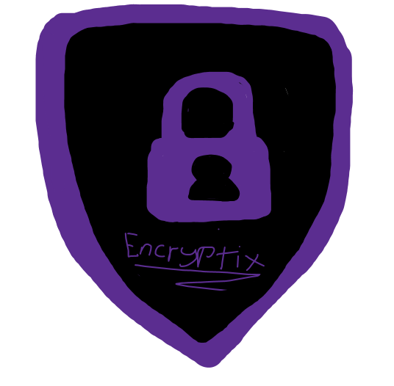

Team Members:
Sean Foran - Eoghan O’Donovan
Bradley Neville - Vitalina Sapozhnik

Supervisor: Hristo Trifonov

Table of Contents
Introduction 4
Background Research 4
Defining encryption and its subtypes 5
What is the importance of encryption in the digital space? 7
Why should a veterinary clinic need to encrypt data? 7
Are there open-source encryption tools? 7
Consultancy Goals 8
What we offer to our clients 8
Objectives 8
Implementation 8
Website 8
First draft: 8
Service Examples Implemented: 8
New Demos: 8
Four Sub sections: 8
Current Website at time of report draft: 8
Demonstration 8
Weekly Trello: 8
Week 3: 8
Week 4: 8
Week 5 8
Website Progression 8
Sources 8
Background Research 8

Introduction
Encryptix is a cybersecurity consultancy dedicated to providing expert encryption solutions and data protection services for veterinary clinics and local to regional businesses. In an increasingly digital world, these organisations often handle sensitive information such as client details, medical records, and financial data without the benefit of a dedicated cybersecurity team. This leaves them exposed to threats such as ransomware, data theft, and system breaches.
Our consultancy was founded to bridge this gap by offering both consultative guidance and hands-on encryption implementation. We work directly with clients to assess their security needs, apply suitable encryption methods, and ensure all data whether stored, transmitted, or backed up is fully protected. Beyond technical solutions, Encryptix also focuses on training staff to understand encryption practices and maintain secure digital habits.
The goal of Encryptix is to make strong, reliable encryption accessible to smaller organisations, helping them achieve compliance, strengthen data integrity, and build long-term resilience against cyber threats.

Background Research

Defining encryption and its subtypes
Encryption is the process of converting data or information to code to prevent unauthorised access. Encryption can be broken up into 4 separate subtypes these are Symmetric encryption, Asymmetric Encryption, Hashing and Hybrid Encryption.

Symmetric encryption
Symmetric encryption is a method of encryption where the same secret key is used to both encrypt and decrypt data. This key must be securely shared between the sender and receiver before any communication can take place. Because it uses a single key, symmetric encryption is typically faster and more efficient than asymmetric encryption, making it ideal for encrypting large amounts of data such as databases, files, or entire drives.
However, the main challenge with symmetric encryption lies in key management — securely distributing and storing the key without it being intercepted. If the key is compromised, the encrypted data can be easily decrypted.
An open-source software that's widely used for Symmetric encryption is BitLocker using the AES algorithm which secures data with a single encryption key. This means that if someone were to steal or lose the physical storage device that the data remains secure since they don't have access to the key.
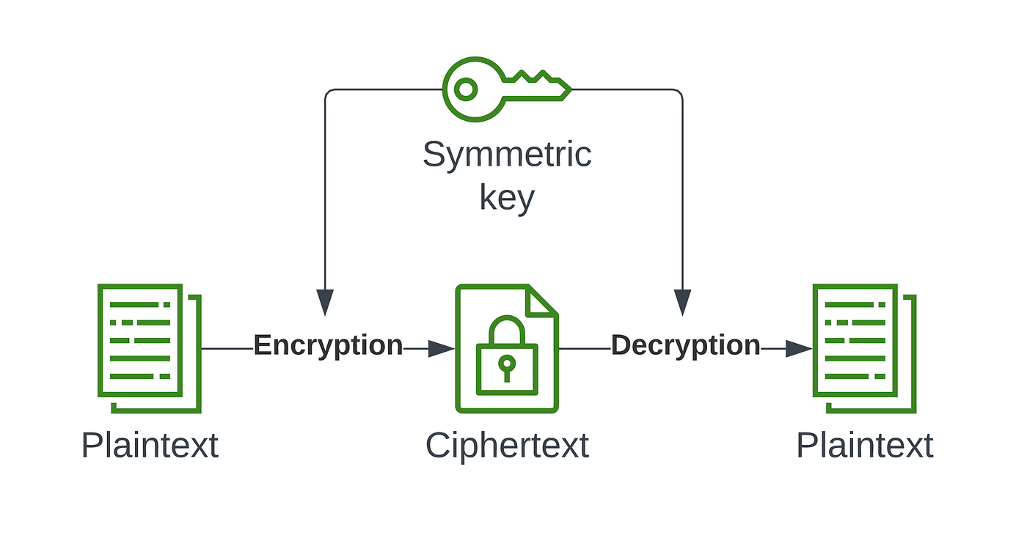

Asymmetric Encryption
Asymmetric encryption (can also be known as public-key encryption) uses two keys instead of one like with symmetric encryption a public key for encryption and a private key for decryption. The public key can be shared openly, while the private key must be kept secret by the owner. When someone encrypts data with a recipient’s public key, only that recipient’s private key can decrypt it, ensuring confidentiality and secure communication even over untrusted networks.

Unlike symmetric encryption, where the same key must be securely shared between parties, asymmetric encryption eliminates the need for direct key exchange, reducing the risk of interception. However, this comes at a cost — asymmetric encryption requires significantly more computational power, making it slower and less efficient for encrypting large volumes of data.

To overcome this, asymmetric encryption is often used to securely exchange keys or verify digital signatures rather than encrypt full data sets. Once the keys are exchanged, symmetric encryption can then be used for faster data transmission. Common asymmetric algorithms include RSA (Rivest–Shamir–Adleman), Elliptic Curve Cryptography (ECC), and Diffie–Hellman key exchange, all of which form the backbone of secure online communication, including HTTPS and email encryption.

An example of an open-source program that uses asymmetric encryption is OpenSSL which provides the asymmetric key pairs during the TLS handshake, the server has access to both keys one of which is kept securely on the server and that one is the private key the one shared with users is the public key. This allows for data to be transmitted securely online.
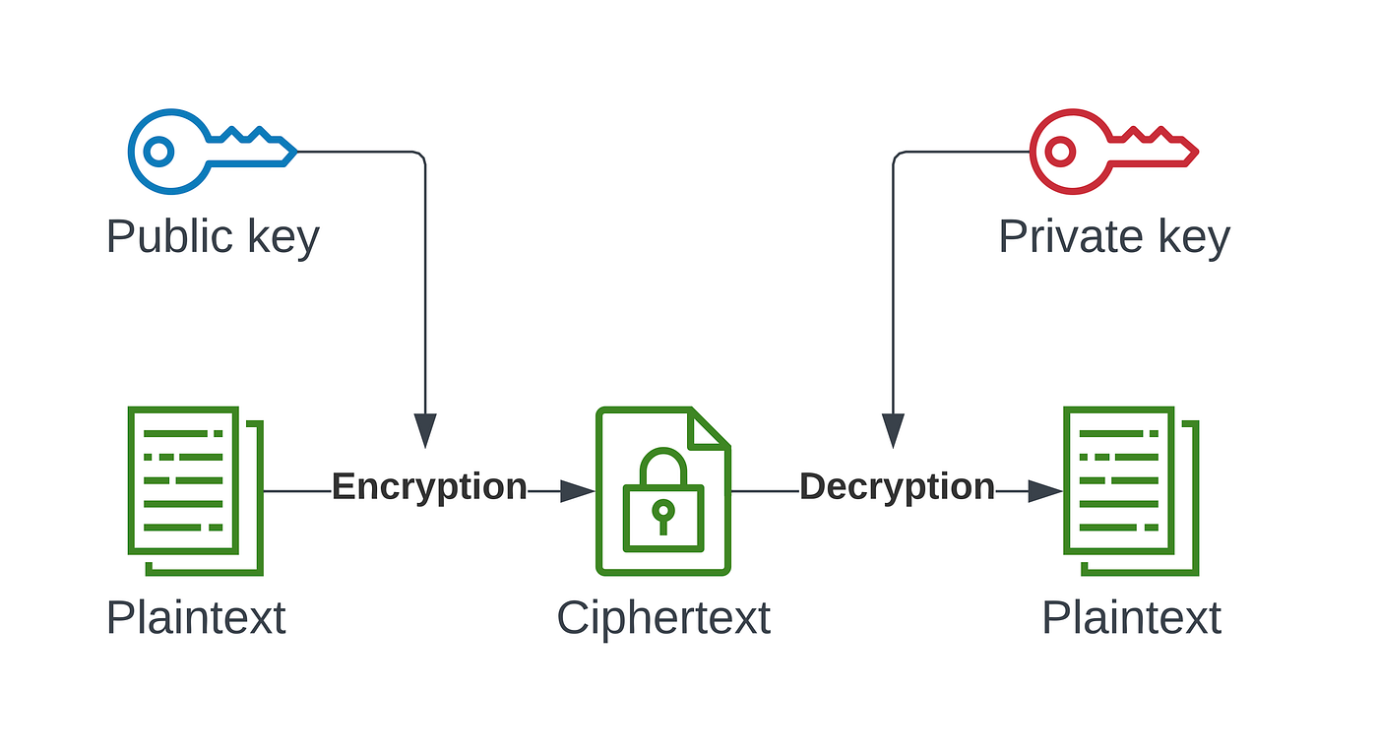

Hashing
Hashing is a process that converts data of any size into a fixed-length string of characters, often referred to as a hash value or digest. Unlike encryption, hashing is a one-way function, meaning the original data cannot be retrieved from the hash. It is commonly used to verify data integrity, such as checking passwords, validating downloaded files, or ensuring that a message has not been altered.
Because hashing always produces the same output for the same input, it allows for quick and reliable comparison of data without revealing the actual content. However, if two different inputs produce the same hash value, this is called a collision, which can pose a security risk.
A popular open-source algorithm used for hashing is SHA-256, part of the SHA-2 family, known for its strong resistance to collisions and tampering.
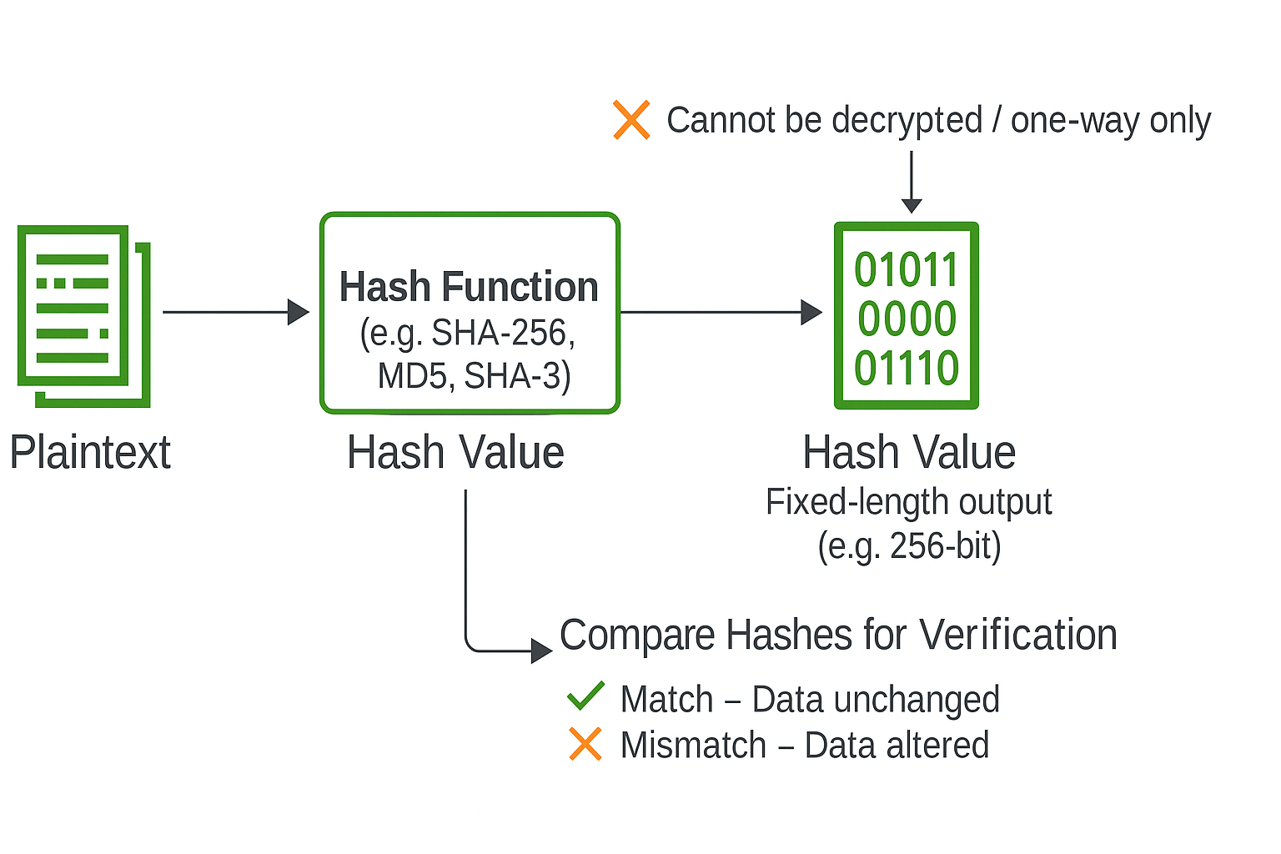

Hybrid Encryption
Hybrid encryption is a method that combines both symmetric and asymmetric encryption to take advantage of their strengths while minimizing their weaknesses. In a hybrid system, asymmetric encryption is used to securely exchange the symmetric key, and the symmetric key is then used to encrypt the actual data.
This approach ensures that the key exchange is secure while maintaining the speed and efficiency of symmetric encryption for large data transfers. Hybrid encryption is widely used in secure communication protocols such as SSL and TLS, which protect data transmitted over the internet.
An example of software that uses hybrid encryption is OpenSSL, which employs public-key cryptography for key exchange and symmetric algorithms like AES for encrypting the data.
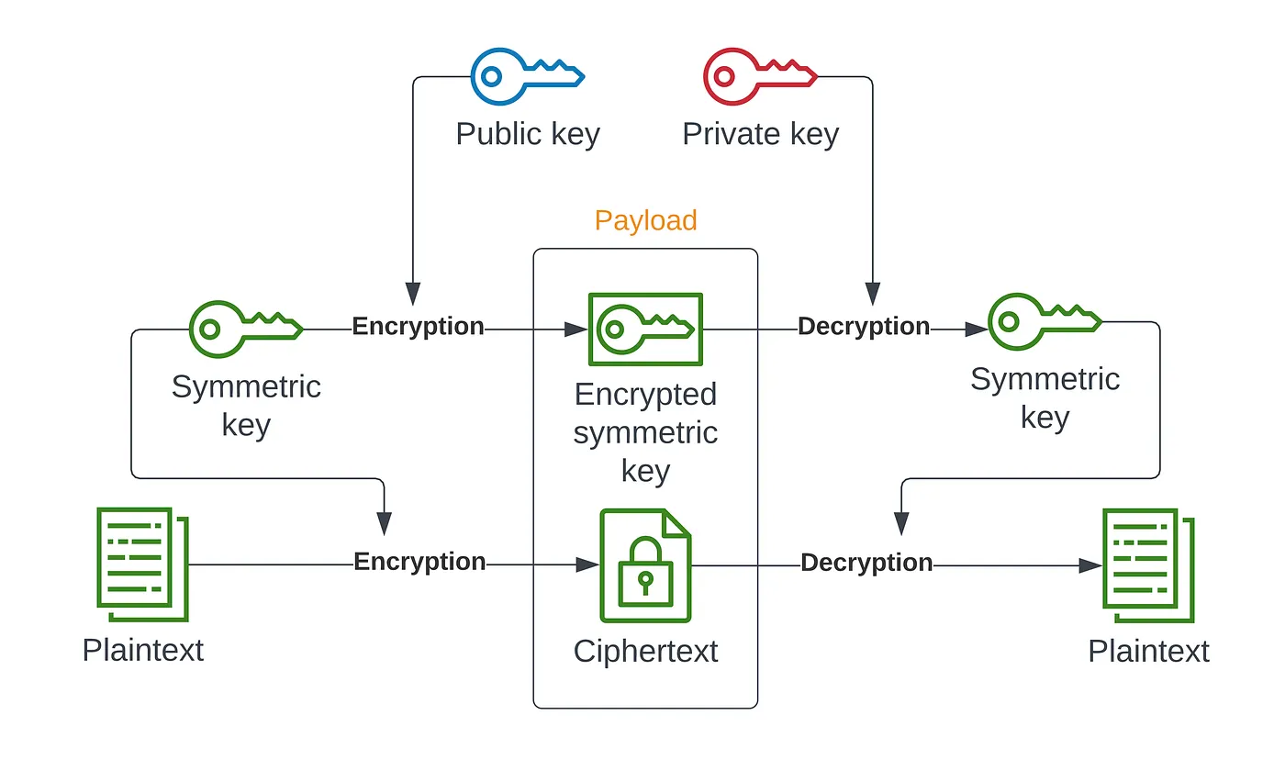

What is the importance of encryption in the digital space?

In today’s digital space, encryption plays a vital role in protecting sensitive data from unauthorised access. As the world increasingly relies on online systems and cloud-based storage, the risk of cyberattacks and data breaches continues to grow. Encryption provides a crucial layer of defence by ensuring that even if information is intercepted, it remains unreadable to outsiders. For our project, this highlights the importance of offering accessible and effective encryption solutions to small businesses and veterinary clinics, helping them maintain data integrity and comply with privacy regulations such as GDPR which dictates that an appropriate level of encryption of a user's personal data such as client payment information is adhered too

Why should a veterinary clinic need to encrypt data?

Veterinary clinics handle large amounts of sensitive information, including client details, payment records, and animal medical histories, all of which must be protected under data protection regulations such as GDPR. Without proper encryption, this data is vulnerable to theft, loss, or unauthorised access — especially as many clinics now use digital systems for appointments, billing, and patient management. Encryption ensures that even if data is intercepted or stolen, it remains unreadable and secure. For vets, this not only safeguards client trust but also protects the clinic’s reputation and ensures compliance with privacy standards in the healthcare sector.

Are there open-source encryption tools?

There are multiple open-source encryption tools available and for different types of encryptions depending on what you want to encrypt. For example, VeraCrypt allows you to encrypt entire hard drives if needed, GNuPG is used to encrypt a user's communication using asymmetric encryption, OpenSSL is used to secure data transmitted over networks and enables the creation and management of SSL/TLS certificates that encrypt traffic between a client and the server.

Consultancy Goals

What we offer to our clients

At Encryptix we offer training to IT staff on how to encrypt your data as well as encrypting business data such as all client information (contact details, address, payment details etc.), encrypting employee communications to avoid any sensitive data from being intercepted by tools such as Wireshark. The types of encryption we provide will depend on client needs if they wish to store sensitive on a drive, we could encrypt it using BitLocker which will generate a single key which only users who our clients deem necessary to know the key will have access to.

We will also provide transport layer security which will encrypt data in transit for which we will be using OpenSSL which will generate two keys (Public and Private) the server will have access to both keys so when a client connects they will use the public key which will encrypt data that will then be decrypted by the server using the private key.

To train our clients IT staff on how to take over if they wish we will provide hands on training, how to remain GDPR compliant and the best practices for key management. The hands-on training we will provide will include training on how to use tools such as Bitlocker to encrypt local data, OpenSSL to secure communication and demonstrating how to verify that a file is encrypted. The training regarding GDPR compliance will teach IT employees on how encryption reduces the risk of liability in the event of a breach and hopefully teaching IT staff the importance of encrypting data in transit aswell as documenting encryption policies for auditing purposes. Training regarding key management will stress the need to rotate keys, how to store encryption keys securely aswell as setting strict access controls to prevent any breaches.

Objectives
Encryptix aims to offer affordable, high-quality encryption services to small-scale companies, bridging the cybersecurity gap between these companies and enterprise level businesses. Many smaller companies often neglect and underestimate their exposure to cyber based risks, due to limited technical resources. This is where Encryptix comes in. Our goal is to design a model that delivers enterprise level encryption, at a manageable and affordable cost. This includes creating procedures that are easy to follow for securing local and cloud-based data, ensuring that sensitive data remains secure, while also complying with GDPR. We also keep in mind that not every enterprise may have specialists in this field as part of their in-house staff, which is why we aim to provide ongoing support without the need for this.
As a company, we understand that technology alone cannot secure a company's stored data, and in-fact may sometimes increase the risks faced. While technology may allow for enhanced security of data, our objective is also to equip staff of companies with the knowledge and confidence to maintain secure digital environments even our services have been implemented. This involves poviding interactive workshops and documentation on topics such as symmetric and asymmetric encryption, hashing, secure password handling, and data classification. By developing a foundation

Implementation

Website

First draft:
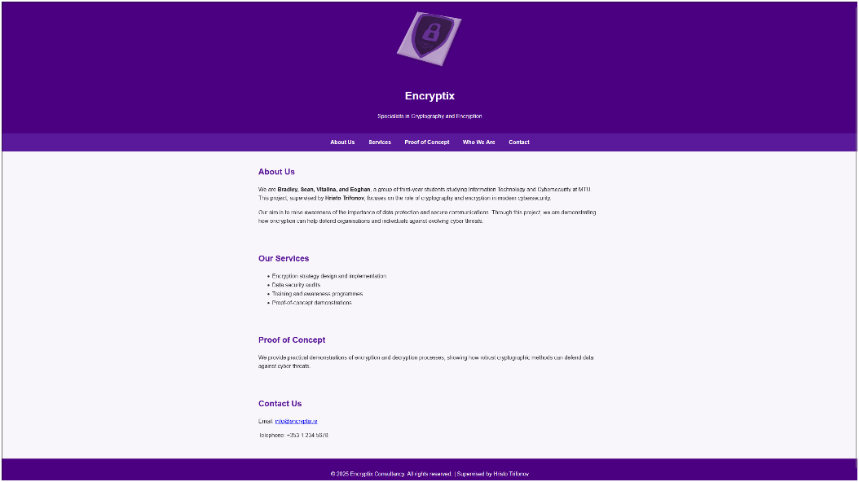
Website was bare at first, we only had two pages:
Our home page containing what we thought we wanted to do. The website progressed as we learned more about our topic and evolved with it.

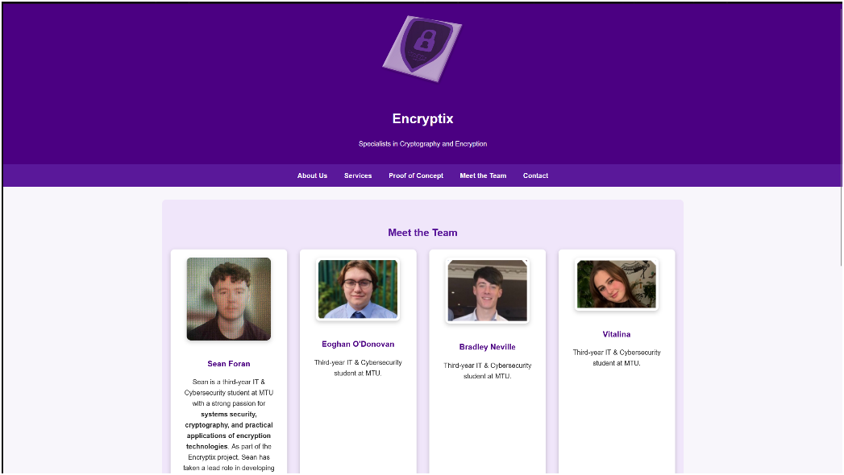
We also had a meet the team page, which featured us and a short writeup about us as people.

Service Examples Implemented:
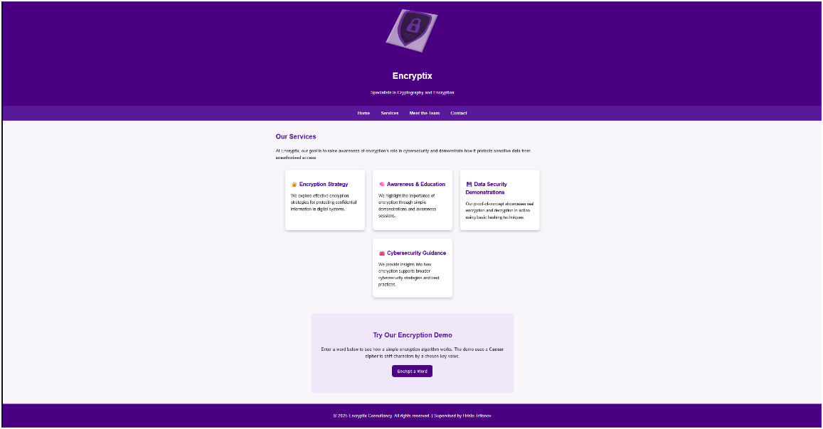
We added a new page, Our services, this page was to show what sort of services we wanted to provide at the time.
The style and colours of our website kept changing as time went on.

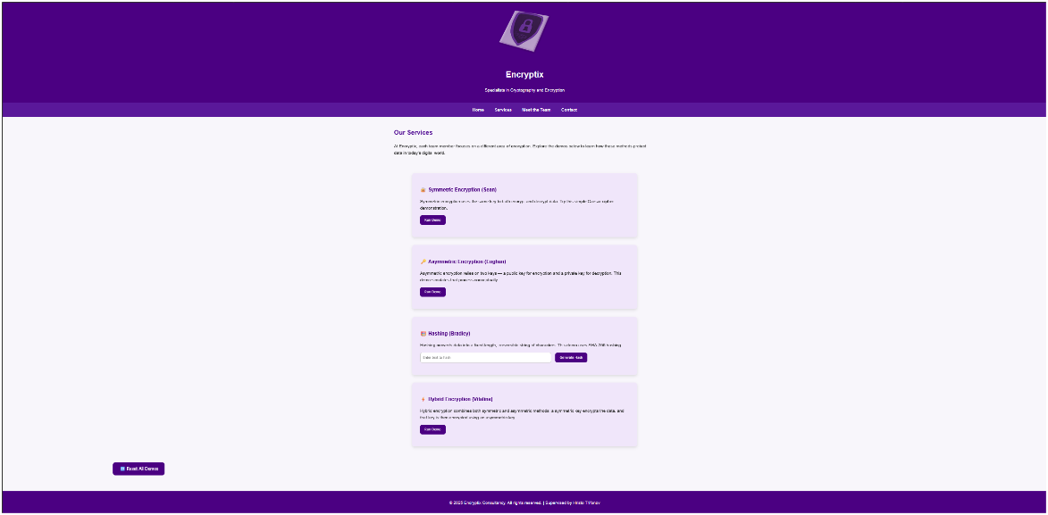
This version of the website also featured our first working demo. It was a very basic ceaser cipher, which shifted the sentence or word entered by 1-25 letters.

Four Sub sections:
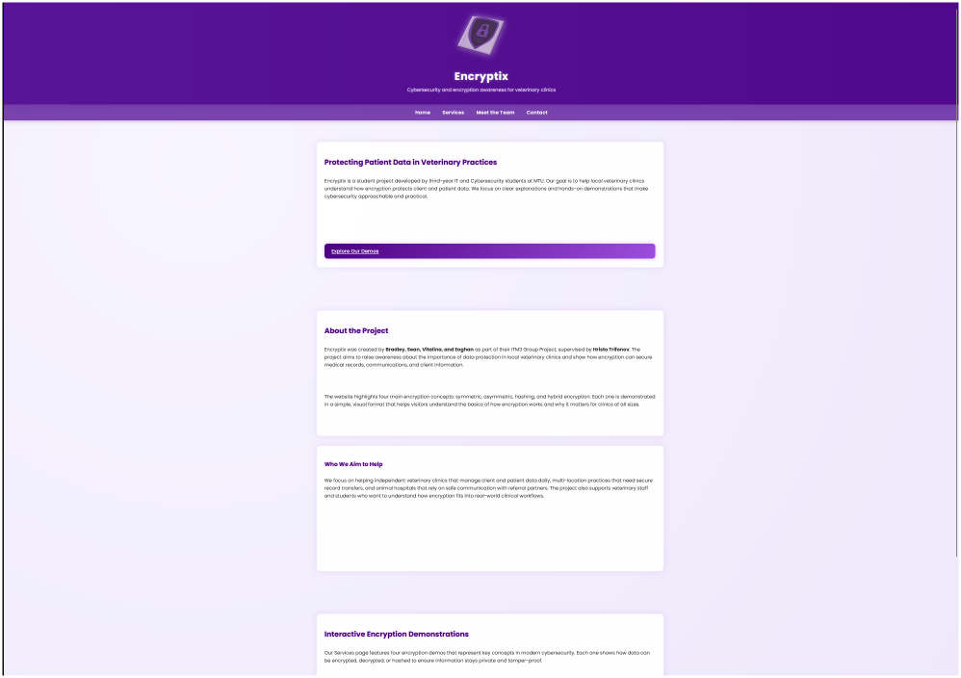
After Shifting to our focalised idea, vet clinics. This was our home page.

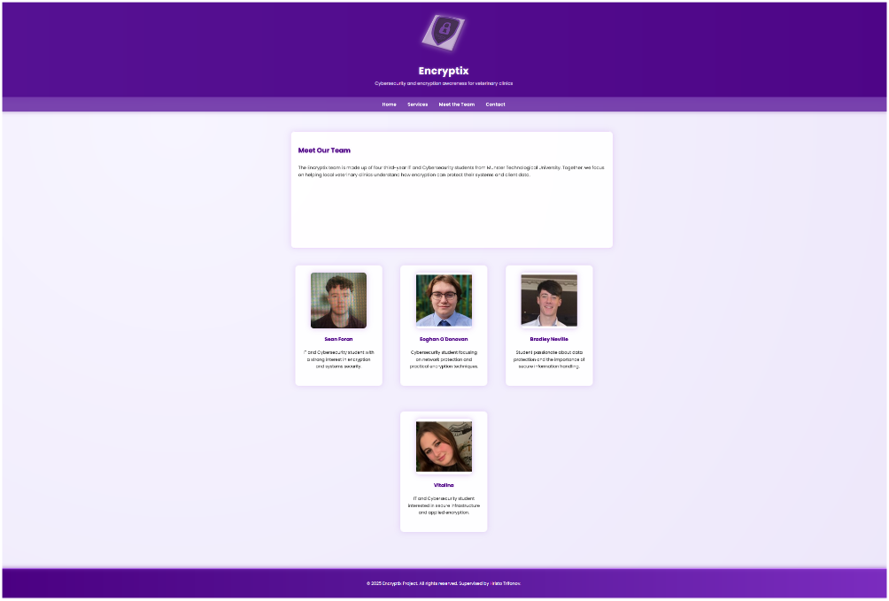
Our meet the team section

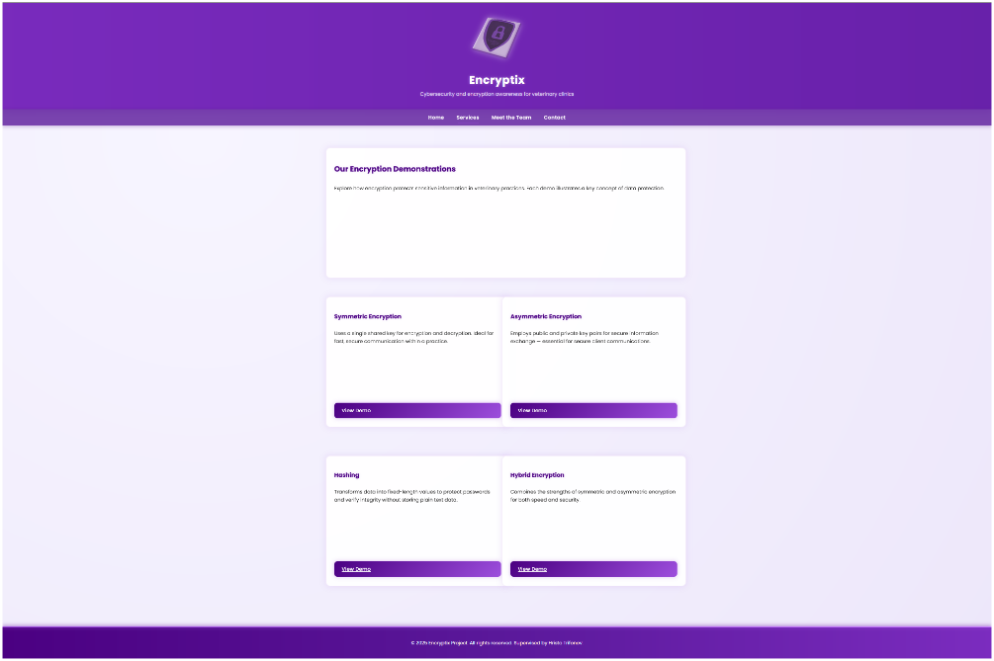
And our services turned into a more of a home menu for the four different type of encryption demos we planned to provide

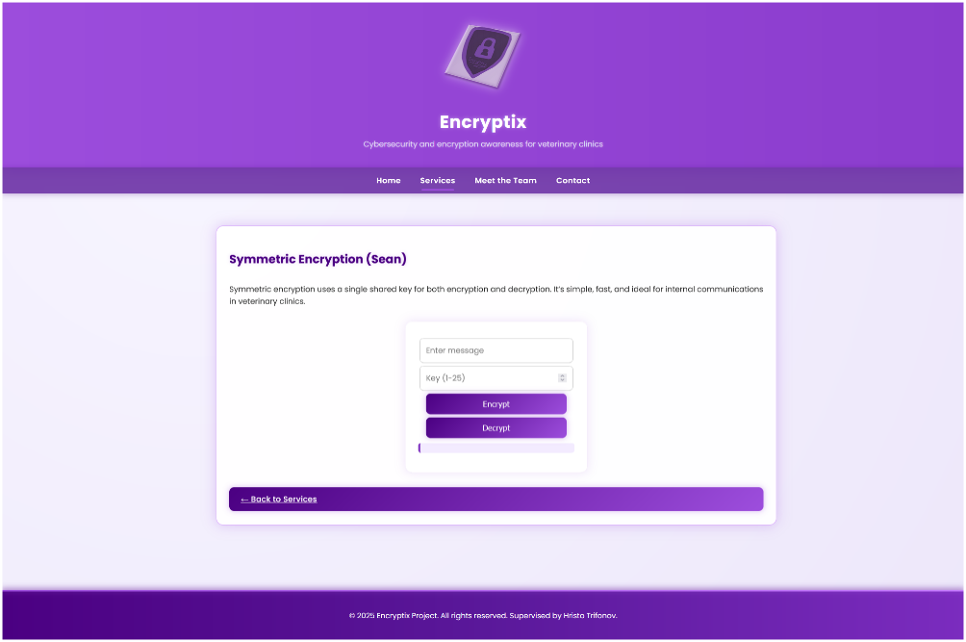
For example, this is what symmetric encryption that sean is focusing on looks like.

Current Website at time of report draft:
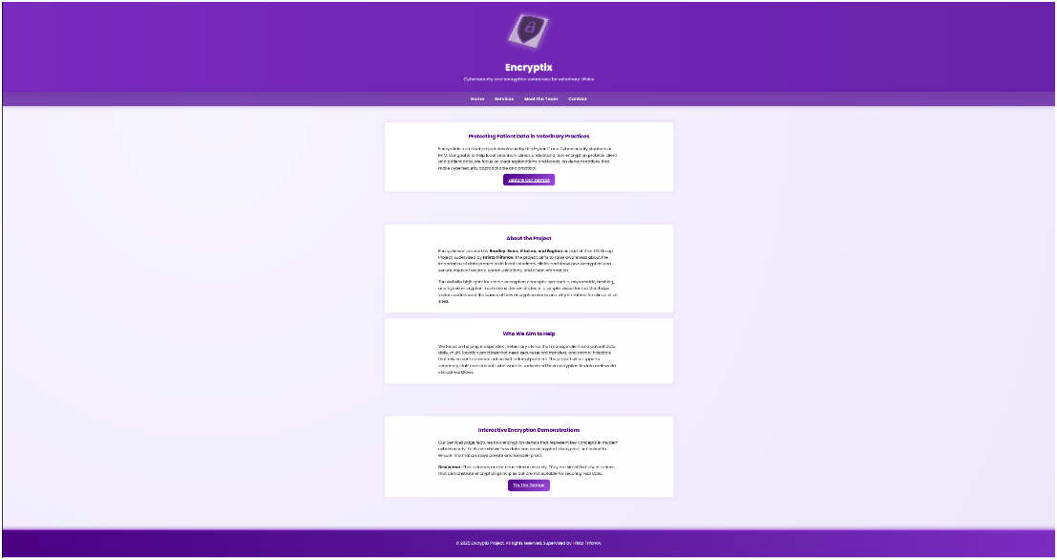
We settled on the styling of our website. There’s an animated header.

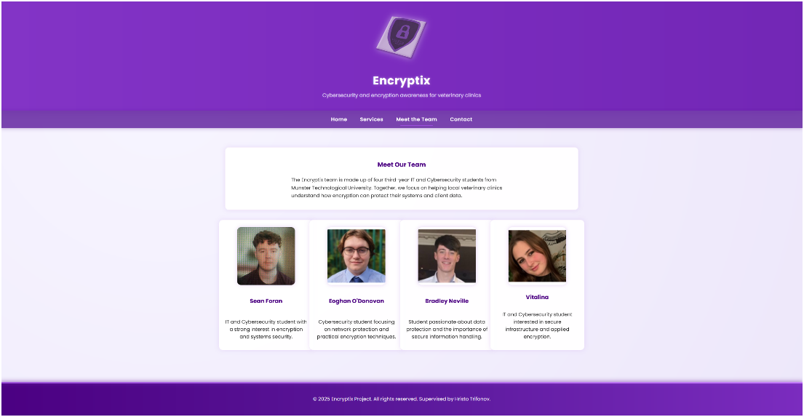
Our meet the team section has the 4 of us lined up.

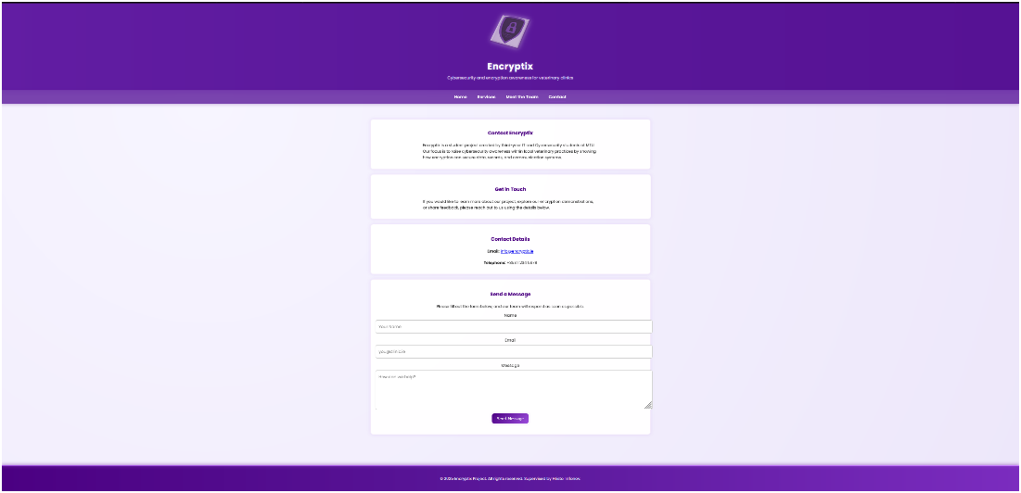

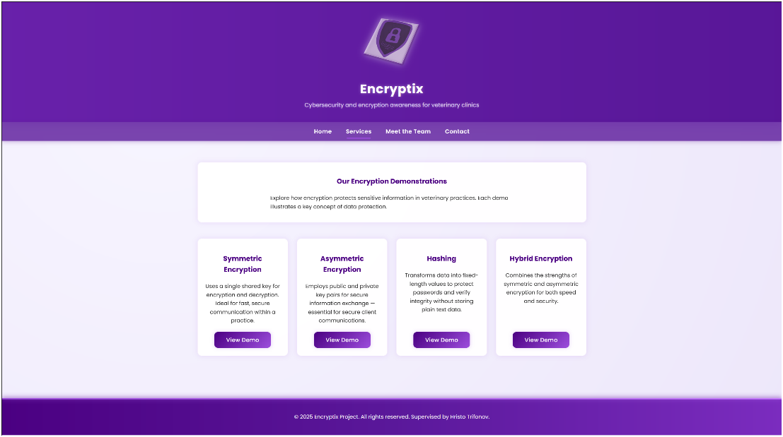
The boxes of our service demo menu also line up with eachother.

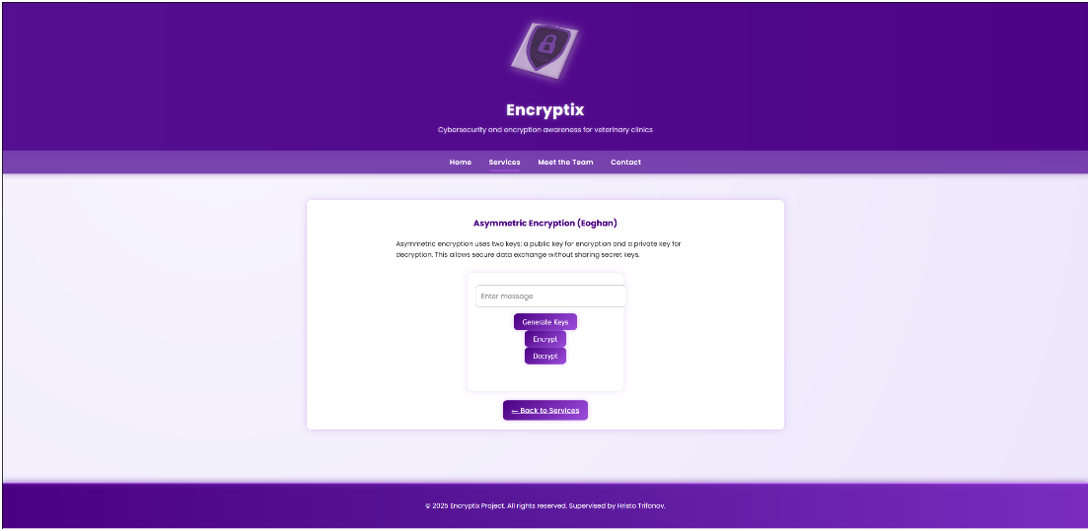

Here is another example of a demo we plan to provide for our client. This one is asymmetric encryption by Eoghan. It creates a public and private key and encypts a

Demonstration

Weekly Trello:
Week 3: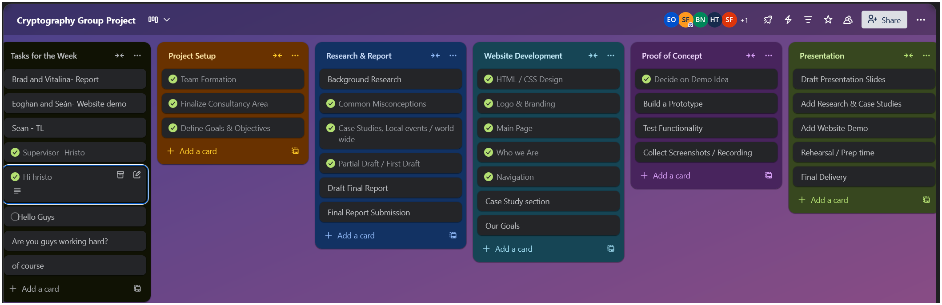
HRISTO NOTES:
WHOS THE PROJECT FOR/ who are we advising?
Vets

Best practices?
Find use cases for everything?
Who are our steak holders?
Four subsections?

Week 4:
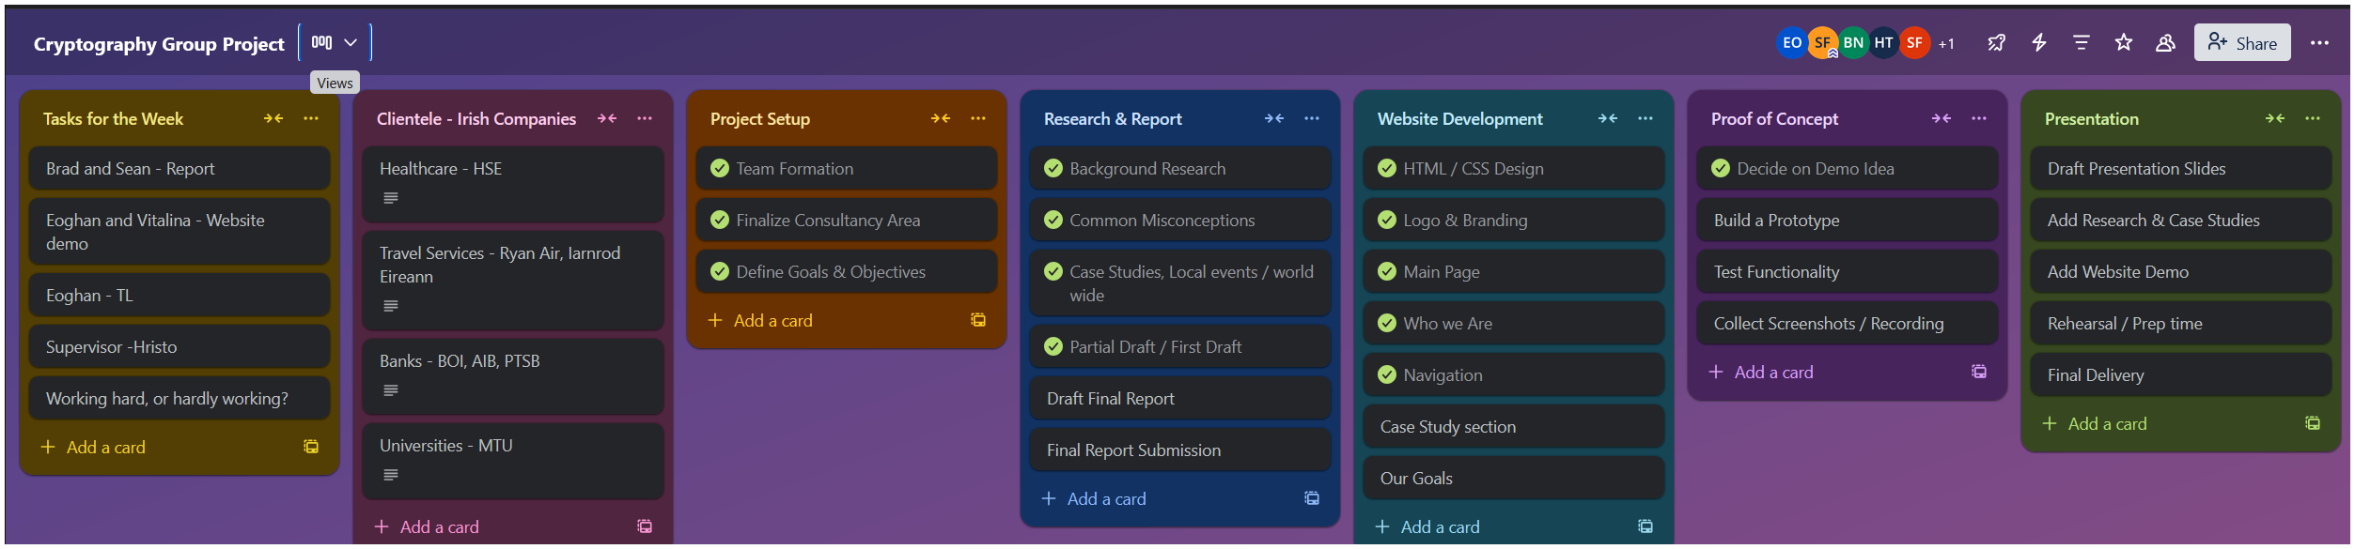

Small business needs to be small and local that would realistically accept a small business to encrypt sensitive data and scale.

Week 5
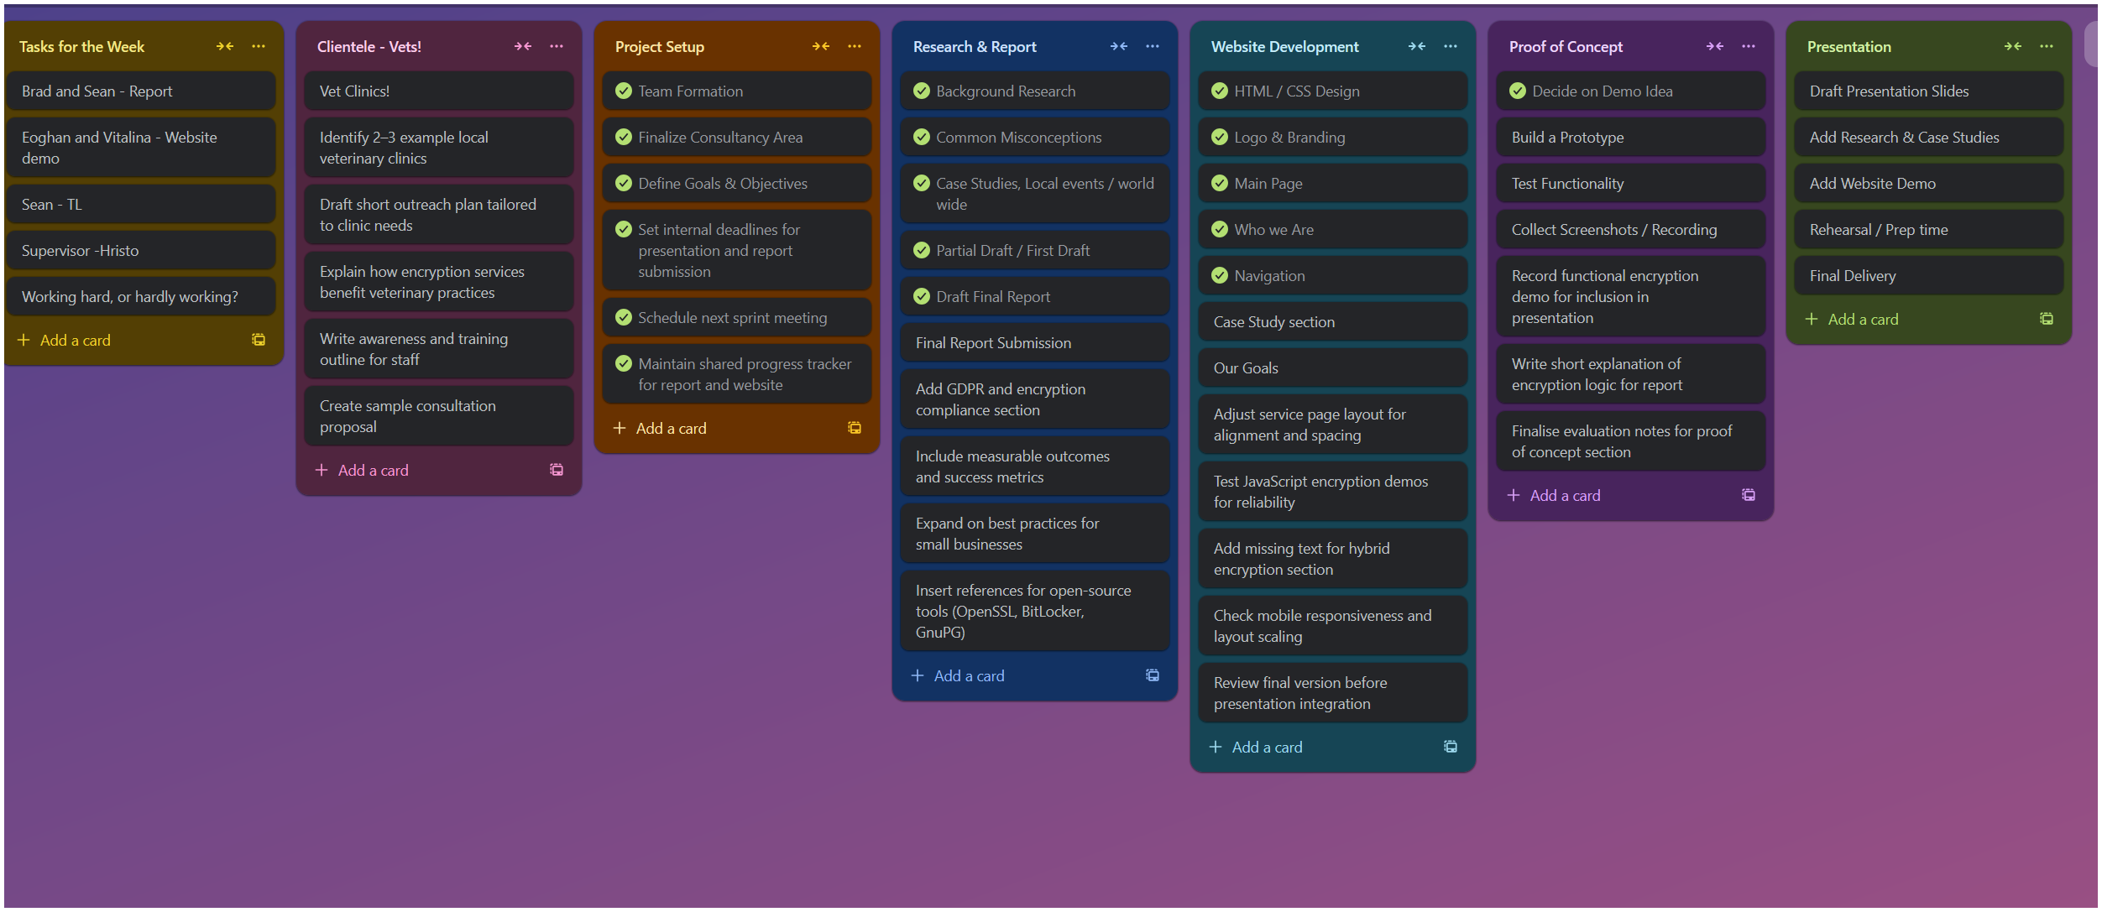

Website Progression
First version, Very basic, Sample pages and navigation bar

Sources

Background Research

https://www.ibm.com/think/topics/symmetric-encryption
https://www.lenovo.com/ie/en/glossary/types-of-encryption
https://medium.com/@igorfilatov/hybrid-encryption-in-python-3e408c73970c

